
COMSATS University Islamabad, Pakistan

E-Garments “Fashion-Webify”

A project presented to
COMSATS Institute of Information Technology, Islamabad

In partial fulfillment of the requirement for the degree of

Bachelor of Science in Computer Science (2022-2026)

By

Yasir Rizwan CUI/SP22-BCS-203/SWL

DECLARATION
We hereby declare that this software, neither whole nor as a part has been copied out from any source. It is further declared that we have developed this software and accompanied report entirely on the basis of our personal efforts. If any part of this project is proved to be copied out from any source or found to be reproduction of some other. We will stand by the consequences. No Portion of the work presented has been submitted of any application for any other degree or qualification of this or any other university or institute of learning.

Yasir Rizwan

- -------------------
CERTIFICATE OF APPROVAL
It is to certify that the final year project “Fashion Webify " was developed by Yasir Rizwan(CUI/SP22-BCS-087/SWL) under the supervision of Ms. Aqsa Kiran and co-supervisor Mr. Ali Sher Kashif. In their opinion, it is fully adequate in scope and quality for the degree of Bachelor of Science in Computer Science.

---------------------------
Supervisor
Ms. Aqsa Kiran
(Department of Computer Science)

---------------------------

---------------------------
Head of Department
Dr. Zafar Roy
(Department of Computer Science)

Executive Summary
Fashion Webify is a contemporary, responsive, and feature-rich e-commerce platform designed to improve the online shopping experience for both customers and fashion retailers. The website enables users to create accounts effortlessly, explore a diverse range of men’s and women’s clothing and accessories, add items to their cart, place secure orders, and track their purchase history. Its goal is to streamline the entire online shopping process by offering a clean, intuitive interface and fast, efficient performance, ensuring a seamless experience from browsing to checkout.
For retailers, the system provides powerful tools for product management, category handling and order tracking. These built-in features help store owners manage their inventory digitally and reduce manual work, while improving overall operational efficiency. By offering an easy-to-manage dashboard, the platform supports small and medium-sized fashion businesses in expanding their online presence.
Fashion Webify is built using the MongoDB, Express.js, React.js, and Node.js which ensures high scalability, performance, and security. React.js delivers a responsive, smooth, and interactive user interface, while Node.js and Express.js handle backend operations, API communication, and user authentication. MongoDB provides an efficient NoSQL database system capable of managing large product catalogs, user profiles, orders, and real-time updates. The website architecture is fully designed to support future enhancements such as payment integrations.
This document provides a comprehensive overview of Fashion Webify, including system requirements, architecture design, implementation details, and testing procedures. The project is developed with a strong focus on usability, security, and reliability, ensuring that both customers and fashion retailers can benefit from a robust and feature-rich online shopping experience.

Acknowledgement
All praise is to Almighty Allah who bestowed upon us a minute portion of His boundless knowledge by virtue of which we were able to accomplish this challenging task.
We are greatly indebted to our project supervisor “Ms. Aqsa Kiran and co-supervisor Mr. Ali Sher Kashif”. Without their personal supervision, advice and valuable guidance, completion of this project would have been doubtful. We are deeply indebted to them for their encouragement and continual help during this work.
And we are also thankful to our parents and family who have been a constant source of encouragement for us and brought us the values of honesty & hard work.

Yasir Rizwan

-----------------

Abbreviations
Abbreviation | Full Form
SRS | Software Requirement Specification
SDD | Software Design Document
API | Application Programming Interface
GPS | Global Positioning System
UX | User Experience
UI | User Interface
SDLC | Software Development Life Cycle
JWT | JSON Web Token
CRUD | Create, Read, Update, Delete
HCI | Human-Computer Interaction
VS Code | Visual Studio Code
UUID | Universally Unique Identifier
NoSQL | Non-Structured Query Language
CI | Continuous Integration
ReactJS | React JavaScript (Web Framework)
Node.js | Node JavaScript (Backend Runtime)
MongoDB | Mongo Database (NoSQL DBMS)
REST | Representational State Transfer
Expo Go | Framework for testing React Native apps
Postman | API Testing Tool

Table of Contents
1 Introduction 2
1.1 Brief 2
1.2 Relevance to Course Modules 3
1.3 Project Background 5
1.3.1 Problem Statement 5
1.3.2 Target Audience 5
1.3.3 Project Objectives 6
1.3.4 Technological Choices 6
1.3.5 System Features 7
1.3.6 Challenges and Innovations 7
1.4 Literature Review 7
1.4.1 OnlineFashion Platforms and Market Trends 7
1.4.2 Technologies for Building E-Commerce Platforms 8
1.4.3 Backend Development 8
1.4.4 Real-Time Order Status Tracking 8
1.4.5 Challenges in Online Fashion Platforms 8
1.4.6 Conclusion from Literature Review 9
1.5 Analysis from Literature Review 9
1.5.1 Real-Time Order Status Tracking 9
1.5.2 Scalable Backend Architecture 9
1.5.3 User Experience (UX) and User Interface (UI) Design 10
1.5.4 Real-Time Data Synchronization 10
1.5.5 Conclusion 10
1.6 Methodology and Software Lifecycle for This Project 10
1.6.1 Rationale behind Selected Methodology 11
2 Problem Definition 14
2.1 Problem Statement 14
2.2 Deliverables and Development Requirements 15
2.2.1 Key Deliverables 15
2.2.2 Development Requirements 16
2.3 Current System 16
2.3.1 Lack of Integration 17
2.3.2 User Experience Challenges 17
2.3.3 Manual Inventory and Product Management 17
3 Requirement Analysis 19
3.1 Use Cases Diagram(s) 19
3.2 Detailed Use Case 24
3.3 Functional Requirements 35
3.3.1 Customer Module 36
3.3.2 Garments Module 36
3.4 Non-Functional Requirements 36
4 Design and Architecture 39
4.1 System Architecture 39
4.2 Data Representation [Diagram + Description] 43
4.3 Process Flow/Representation 49
4.4 Design Models 54
4.4.1 Sequence Diagram 54
4.4.2 Class Diagram 58
5 Implementation 65
5.1 Backend Implementation 65
5.2 Customer Web Portal Implementation 65
5.3 User Interface 66
5.5.1 Web Interface (ReactJS) 66
6 API Reference 68
6.1 Authentication 68
6.2 Profile Management 68
6.3 Product Items 69
6.4 Garments Discovery (Customer) 70
6.5 Orders & Checkout 70
6.6 Reviews & Ratings 71
6.7 Media Handling 71
6.8 Real-Time Features (Socket.IO) 71
6.9 Customer Events 71
6.10 Garments Events 72
7 Testing and Evaluation 74
7.1 Manual Testing 74
7.1.1 System testing 74
7.1.2 Unit Testing 74
7.1.3 Functional Testing 75
7.1.4 Integration Testing 76
7.2 Automated Testing: 77
8 Conclusion and Future Work 79
8.1 Conclusion 79
8.2 Future Work 79
References 80

List of Figures
Figure 3. 1 Use Case 19

Figure 4. 1 Architecture Diagram 39
Figure 4. 2 ER Diagram 44
Figure 4. 3 Process flow 50
Figure 4. 4 Sequence Diagram 54
Figure 4. 5 Class Diagram 58

List of Tables
Table 3. 1 Feature Category for use case 23

Table 4. 1 Benefits of Architecture Diagram 42
Table 4. 2 Relationships Summary 47
Table 4. 3 Class Diagram Relationship 62

Table 6. 1 Customer Authentication Routes 68
Table 6. 2 Garments Authentication Routes 68
Table 6. 3 Customer Profile Management Routes 68
Table 6. 4 Garments Profile Management Routes 69
Table 6. 5 Product Items (Garments) 69
Table 6. 6 Garments t Discovery (Customer) 70
Table 6. 7 Customer Orders & Checkout 70
Table 6. 8 Garments Orders & Checkout 70
Table 6. 9 Reviews & Ratings 71
Table 6. 10 Media Handling 71
Table 6. 11 Namespaces Real-Time Features (Socket.IO) 71
Table 6. 12 Customer Events 71
Table 6. 13 Garments Events 72

Table 7. 1 Unit Test 1 74
Table 7. 2 Unit Test 2 75
Table 7. 3 Functional Test 76
Table 7. 4 Integration Test 76
Table 7. 5 Tool Used 77

Chapter 1

Introduction

Introduction
The e-commerce sector has seen significant expansion over the last decade, reshaping how people purchase clothing and fashion items. As digital adoption increases and customer habits evolve, online shopping has become the preferred option because of its convenience, range of choices, and easy accessibility. Although many online shopping platforms have emerged, a large number still struggle to deliver a consistent and user-friendly experience for both customers and store owners. Issues remain in areas such as building fully responsive websites, managing products efficiently, ensuring secure order processing, and enabling smooth communication between buyers and sellers.
Fashion Webify is a full-stack based solution developed to address these challenges by offering a smooth, scalable, and user-friendly online shopping ecosystem. Built using modern technologies including MongoDB, Express.js, React.js, and Node.js Fashion Webify bridges the gap between customers and fashion retailers, ensuring a streamlined and efficient digital purchasing experience.
The core idea behind Fashion Webify is to provide a flexible, easy-to-use online clothing platform where customers can browse categories, view product details, manage their cart, and place secure orders with ease. The backend is designed with a strong focus on scalability, ensuring that large collections of products, customer profiles, and order information can be stored and managed efficiently using MongoDB. Meanwhile, the front-end UI is designed to be clean, responsive, and user-friendly, enabling smooth navigation across all devices.
This project follows modern development principles, prioritizing modularity, maintainability, and user-centric design. The platform is built to support future growth, allowing for the easy integration of features such as online payment gateways and delivery tracking systems as the system evolves.
The following sections of this report will offer an in-depth overview of the project’s background, its connection to course modules, related literature, chosen methodology, and system design, along with the justification for using the MERN stack. By presenting a thorough analysis, this report intends to deliver a clear understanding of the project’s structure, goals, and how it aligns with current industry practices and academic expectations.

Brief
The rise of digital technologies has greatly reshaped the retail and fashion sector, giving way to online shopping platforms that address the changing expectations of both consumers and businesses. Fashion Webify is a full-stack, web-based e-commerce system built to simplify and improve interactions between customers and clothing retailers. Using modern tools like Node.js, Express.js, MongoDB, and React.js, Fashion Webify delivers a unified platform that boosts user experience, improves operational workflows, and supports long-term scalability.
The platform is architected to support two primary user roles: Customers and Admin/Retailers. Each role is provided with dedicated features tailored to their specific needs and workflows.
Customer Interfaces
- Web Application
Built with React.js, the web interface offers similar functionalities, ensuring accessibility across various devices and platforms.
Website Interface
At the heart of Fashion Webify is a strong backend architecture built with Node.js and Express.js, while MongoDB functions as the main database. This backend framework manages API routes, user authentication, core business logic, and data operations, ensuring smooth interaction between the frontend interface and the database. The platform uses RESTful APIs and a modular structure, making the system easy to maintain and highly scalable for future enhancements.
- User Authentication and Authorization
Secure login and role-based access control mechanisms to ensure data privacy and integrity.
- Product Management
Dynamic product listing creation and editing capabilities for clothing retailers.
- Order Processing
Real-time order placement, tracking, and status updates to enhance customer satisfaction.
- Review System
Feedback and rating functionalities to foster trust and continuous improvement.
- Responsive Design
User-friendly interfaces optimized for both mobile and web platforms.
The development of Fashion Webify adheres to modern software engineering principles, emphasizing modularity, scalability, and user-centric design. By integrating cutting-edge technologies and best practices, the platform aims to provide a reliable and efficient solution for the contemporary e-shopping service industry.

Relevance to Course Modules
The development of Fashion Webify directly applies knowledge and skills acquired in various course modules typically found in software engineering and computer science curricula. The project not only serves as a practical application of theoretical concepts but also integrates multiple areas of study, enhancing the understanding of full-stack development, mobile application development, database systems, and software engineering methodologies. Below are some key course modules that are highly relevant to this project.

- Web Technologies
Fashion Webify encompasses the entire web development lifecycle, from backend architecture to frontend user interfaces. The backend is powered by Node.js and Express.js, following the principles of RESTful API design and middleware management. On the frontend, the project utilizes React.js, implementing responsive UIs for both mobile and web applications. The seamless interaction between these layers mirrors the content and skills taught in full-stack web development courses, which often focus on creating scalable, API-driven systems.

- Database Systems
Fashion Webify uses MongoDB, a NoSQL database, to store data related to users, orders, garments, and reviews. This system demonstrates an understanding of document-based databases, schema design, and the implementation of CRUD operations. It reflects concepts taught in database systems courses, including data modeling, query optimization, and the benefits of using NoSQL databases for flexible, scalable applications.

- Human-Computer Interaction (HCI)
Human-Computer Interaction (HCI) principles are applied in the design of the user interfaces for both customers and garment owners. The project focuses on creating intuitive, responsive, and aesthetically pleasing UI components that prioritize user experience (UX). The importance of making the system accessible and easy to use, as well as gathering feedback from real users, is a key aspect taught in HCI courses and integrated throughout the development of Fashion Webify .

- System Design and Architecture
The platform architecture of Fashion Webify adheres to modular design principles, ensuring clear separation between the different components of the system (i.e., backend, web portal). This follows core architectural concepts taught in system integration and architecture modules, such as API-driven development, communication between distributed systems, and scalable software design.
- Software Project Management
The development of Fashion Webify also incorporated key project management practices, including setting milestones, prioritizing tasks, and maintaining proper documentation. A well-organized README file and consistent commit history reflect adherence to effective project management and version control principles emphasized in academic coursework.
Through this project, the Fashion Webify team has been able to integrate knowledge from multiple academic disciplines, reflecting the comprehensive nature of modern software development. The ability to tackle both backend and frontend challenges, while ensuring a focus on user experience, highlights the multidimensional learning that occurs through such an endeavor.

Project Background
The Fashion Webify project was developed in response to the increasing need for efficient and well-organized online shopping platforms within the fashion and retail sector. As digital clothing stores continue to grow, customers now expect smooth, personalized experiences when exploring and purchasing apparel from their favorite brands. At the same time, retailers need powerful tools to handle products, inventory, customer engagement, and sales insights. Yet many existing platforms do not fully meet these requirements in a flexible or user-friendly way. Problem Statement
Many existing clothing and fashion e-commerce platforms come with notable limitations, such as weak integration with retailer-specific systems, ineffective handling of product listings, and a lack of comprehensive tools for store owners to control inventory, product information, and customer engagement. From the user’s standpoint, numerous websites provide inconsistent interfaces and limited options for browsing and completing purchases. Additionally, on the backend side, several platforms face challenges related to scalability, maintainability, and smooth interaction among core components such as users, products, and orders.
The Fashion Webify project was thus initiated to create a more flexible, scalable, and user-centric e-commerce platform. Its primary goal was to design a comprehensive system that could address the pain points faced by both customers and retailers, offering them a seamless experience from product selection to order completion.

Target Audience
Fashion Webify is developed to serve two primary categories of users
- Customers
Individuals who wish to shop for clothing and fashion accessories via an intuitive web platform. Customers can browse product categories, view detailed product descriptions, add items to their cart, place orders securely, and track the status of their purchases.
- Garments Owners
Store owners and managers who wish to manage their online store, update product listings, monitor inventory, track orders, and view sales analytics. The system also provides insights to help retailers optimize their operations and inventory management.
In addition to the customer and Owner-facing interfaces, Fashion Webify provides an administrative dashboard for overseeing the platform’s overall operations.

Project Objectives
The main objectives of the Fashion Webify project include
- Empowering Garment Owners
Providing Garment owners with the tools they need to efficiently manage their operations, including real-time order status tracking, product management, and sales information.
- Scalable Architecture
Building a scalable backend using Node.js, Express.js, and MongoDB to handle growing amounts of data and users without compromising performance or reliability.

Technological Choices
To meet the project’s objectives, the following technologies were selected:
- Node.js
Used for building the backend APIs due to its scalability and high performance for handling concurrent connections.
- Express.js
A lightweight framework that simplifies routing and middleware management for the backend.
- MongoDB
A NoSQL database that is highly flexible, making it suitable for handling dynamic data structures like product listings, customer orders, and user profiles.
- React.js
Used for building the customer-facing website, offering a responsive and interactive user experience.

System Features
The Fashion Webify system incorporates various features to enhance both the customer and retailer experience:
- Customer Features
Order history, product browsing, reviews, order status tracking, shopping cart management, and profile management.
- Garment Owner Features
Product listing creation, inventory management, profile management, sales analytics, order status tracking, and real-time updates.

Challenges and Innovations
Developing a platform like Fashion Webify required overcoming several technical and operational challenges
- Scalability
Designing the backend to scale as more users and garment owners are onboarded without compromising performance.
- Real-Time Order Processing
Ensuring that orders placed by customers are immediately visible to garment owners for timely processing and shipmen.
- Cross-Platform Compatibility
Ensuring that the website works seamlessly across a wide range of devices, screen sizes, and browsers.
The project also involved innovative solutions for creating dynamic product listings, managing inventory efficiently, and ensuring high security for both customer and garment data.

Literature Review
Over the past decade, the e-commerce and online fashion retail sector has experienced rapid expansion, fueled by shifting consumer habits, technological innovations, and wider internet access. The success of global platforms like Amazon, ASOS, and Zara Online has inspired the creation of similar systems, making the market highly competitive and dynamic. This literature review examines various elements of the online fashion retail industry, including the technologies employed, critical design considerations, and challenges addressed in previous studies and implementations. It also highlights backend systems, web development, and database design, which are essential for projects such as Fashion Webify.
Several studies have investigated the challenges and opportunities in this sector, focusing on aspects such as customer satisfaction, user retention, and the effects of personalized shopping experiences. For example, Smith et al. (2020) emphasized the significance of effective product recommendation systems and the necessity for businesses to enhance user engagement and order processing. Similarly, Lee et al. (2021) explored how responsive web platforms contribute to improved customer interaction and a smoother shopping experience. [2]

Technologies for Building E-Commerce Platforms
Building online fashion retail platforms requires the integration of several core technologies, such as backend frameworks, web interfaces, and databases. Numerous e-commerce systems adopt modular or microservices architectures to provide flexibility and scalability in their backend, enabling individual services to scale independently and simplifying overall system maintenance.

Backend Development
The backend of Fashion Webify platforms typically relies on Node.js [3] and Express.js for their ability to handle asynchronous operations efficiently. Research by Mahajan and Gupta (2019) discusses the advantages of using Node.js in high-traffic environments due to its non-blocking I/O architecture, which allows for processing multiple requests concurrently. Additionally, Express.js provides a minimalistic framework for developing APIs, making it an ideal choice for building scalable and maintainable backend services. [4]
A key component of the backend is the database, and many E-Fashion systems prefer NoSQL databases like MongoDB due to their flexibility in handling unstructured data. MongoDB allows for dynamic schemas, making it suitable for applications where the data model is subject to change frequently.

Real-Time Order Status Tracking
Real-time order tracking is a crucial feature for e-commerce platforms, enabling customers to follow their orders from placement through shipment to delivery. Wu et al. (2019) examined how implementing real-time tracking improves user experience and customer satisfaction. Additionally, real-time notifications that inform users of order updates play a key role in boosting engagement. The Fashion Webify project intends to incorporate these functionalities by using WebSocket or similar technologies to deliver instant updates to customers.

Challenges in Online Fashion Platforms
Despite the rapid expansion of online fashion platforms, developers still face several challenges. A major concern is scalability; as platforms expand and the user base grows, the system must efficiently manage a high volume of simultaneous orders and product catalog requests without performance drops. Li et al. (2018) explored approaches to enhance e-commerce scalability, including optimized database design, load balancing techniques, and cloud-based solutions.
Another challenge is real-time data synchronization. For instance, when a customer places an order, the system must ensure that the garment owner receives it immediately, and the order status is updated in real-time across all interfaces. Zhao et al. (2020) highlighted the importance of event-driven architecture for handling these requirements, where events are triggered when specific actions occur, such as order placement or payment. [2]

Conclusion from Literature Review
The review of current literature indicates that successful e-commerce platforms in the fashion sector rely on a well-integrated combination of backend technologies and database systems. By utilizing Node.js, Express.js, and MongoDB, projects such as Fashion Webify can take advantage of modern tools to achieve scalability, high performance, and maintainability. Furthermore, incorporating real-time updates and responsive web development with frameworks like React.js aligns with contemporary best practices in the online retail industry.

Analysis from Literature Review
The insights drawn from the literature review provide a foundational understanding of the key factors and technologies that contribute to the development of successful e-commerce platforms. By applying these findings, the Fashion Webify project can navigate common industry challenges while taking advantage of modern technologies to build an efficient, scalable, and user-friendly online shopping system. This analysis ties together the best practices from previous research and aligns them with the objectives and requirements of Fashion Webify .

Real-Time Order Status Tracking
As noted in the literature, real-time order tracking plays a critical role in ensuring customer satisfaction on e-commerce platforms. Research by Wu et al. (2019) and Zhao et al. (2020) highlights the importance of providing immediate status updates for both customers and clothing retailers. This supports one of the main goals of Fashion Webify: improving the user experience by delivering precise and timely order information. [2]

Scalable Backend Architecture
The issue of scaling e-commerce platforms as they expand is frequently highlighted in the literature. Li et al. (2018) note that platforms must be designed with scalability in mind, particularly as the number of users and retailers grows. Fashion Webify addresses this challenge by utilizing Node.js, Express.js, and MongoDB to build a flexible, high-performance backend. Node.js is well-suited for managing multiple simultaneous requests thanks to its non-blocking I/O model, which is essential for platforms with many users placing orders at the same time. MongoDB’s flexible schema allows Fashion Webify to scale its database efficiently without strict structural limitations. Whether managing customer orders, product listings, or user profiles, MongoDB offers a versatile and scalable solution for the diverse data handled by the platform.

User Experience (UX) and User Interface (UI) Design
UI/UX design is a key factor in user satisfaction, as highlighted by Norman (2013), who stresses that intuitive and accessible interfaces are essential for online platforms. For an e-commerce system like Fashion Webify, providing easy navigation and a smooth checkout process is critical to maintaining user engagement and reducing cart abandonment rates. [5]

Real-Time Data Synchronization
The need for real-time data synchronization across multiple platforms is another critical element discussed in the literature. As noted by Zhao et al. (2020), e-commerce platforms must ensure that when an order is placed, the data is immediately reflected across all relevant systems. For Fashion Webify , this means that once a customer places an order, the garment owner should receive the order in real-time, and both the customer and garment owner should be able to view the order's status without delay.
Fashion Webify plans to implement event-driven architecture to ensure smooth synchronization between customers, garment owners, and the admin dashboard. By employing event-driven messaging (e.g., via WebSocket), the platform will ensure that order status changes (e.g., order confirmed, processing, shipped, delivered) are communicated instantaneously across all relevant interfaces. This ensures that customers can track their orders accurately, and garment owners can make timely decisions based on real-time data. [2]

Conclusion
The review of existing literature has highlighted several important insights that guide the development of Fashion Webify. By incorporating real-time data updates, scalable backend technologies, responsive web design, and user-focused interfaces, Fashion Webify aims to tackle key challenges in the online fashion retail sector while delivering an optimal experience for both customers and clothing retailers.

Methodology and Software Lifecycle for This Project
The project was developed following the Incremental Software Development Life Cycle (SDLC), enabling the team to construct the application through successive iterations. Each increment focused on specific functional modules, including user registration/login, product catalog browsing, order placement, payment processing, and order tracking. Modules were individually tested and validated before being integrated into the complete system. This approach offered flexibility, allowed early identification of issues, and provided opportunities for continuous improvement.

Rationale behind Selected Methodology
The Incremental Model was selected for the Fashion Webify project because of its flexibility, iterative nature, and emphasis on gradual enhancements. This methodology breaks the project into smaller, manageable increments, each introducing a defined set of features. Every increment is developed, tested, and delivered in stages, enabling continuous refinement and adjustments in response to user feedback and evolving requirements.
The decision to adopt the Incremental Model is driven by the following key factors:

Flexibility and Adaptability
The Incremental Model offers considerable flexibility, making it well-suited for projects like Fashion Webify, where requirements may change over time. By releasing features in stages, the development team can respond to user feedback and evolving market needs after each phase. This iterative strategy enables ongoing improvements without requiring a full system redesign, which is especially advantageous in the fast-moving online retail sector, where user preferences and technology trends can change rapidly.

Early Deliverables and Feedback
Using the Incremental Model, portions of the application can be delivered early and tested in real-world conditions, providing valuable feedback from both garment owners and customers. For instance, initial increments might include basic features such as product browsing and order placement, while later increments could introduce advanced functionalities like order tracking. Early feedback helps identify potential issues before they escalate, ensuring the final product closely aligns with user expectations.

Risk Management
The Incremental Model facilitates the early identification and management of risks at every development stage. By concentrating on smaller, more manageable segments of the project, potential risks related to features, scalability, or security can be detected and addressed before they escalate. For example, if any issues occur with the backend architecture during the initial increments, they can be resolved prior to implementing more complex functionalities, such as real-time order tracking or inventory management.

Continuous Improvement
By dividing the project into increments, the development team can concentrate on delivering value with each iteration, enabling the product to evolve progressively. Each increment builds upon the insights gained from previous stages, enhancing both feature quality and overall user experience. This incremental approach also supports the continuous integration of new functionalities and improvements, allowing for thorough testing and quality assurance before every release.

Clear Milestones and Progress Tracking
The Incremental Model also provides clear milestones, making it easier to track progress. Each increment represents a tangible, deliverable product that can be tested and reviewed, allowing both the development team and stakeholders to assess the status of the project. These milestones provide a clear roadmap, ensuring that Fashion Webify stays on track and progresses toward the final goal.

Support for Ongoing Development
Given the nature of the Fashion Webify project, which is designed to be continuously updated and enhanced based on user needs, the Incremental Model is well-suited for the ongoing maintenance and evolution of the platform. As new technologies emerge or customer preferences change, new increments can be added to the platform without disrupting existing functionality.
For instance, after the initial launch of the core features, Fashion Webify can continue to add additional functionalities like loyalty programs, promotions, and advanced analytics in subsequent increments.

Conclusion
The Incremental Model offers an ideal framework for the Fashion Webify project, providing flexibility, early user feedback, risk mitigation, efficient resource use, and ongoing enhancement. By delivering the platform in manageable increments, the development team can ensure the system remains adaptable, scalable, and responsive to the needs of both customers and garment owners. This methodology aligns with the project’s objective of creating a high-quality, user-focused e-commerce platform that evolves based on user feedback and changing market requirements.

Chapter 2

Problem Definition

Problem Definition
The Fashion Webify project seeks to tackle the challenges present in the online fashion retail sector, focusing on the complexities faced by both garment owners and customers on e-commerce platforms. The online fashion market is growing rapidly, driving demand for efficient, user-friendly solutions that link consumers with clothing and accessory retailers. Yet, many current platforms fall short in providing seamless integration, intuitive user interfaces, and robust backend systems necessary for smooth order processing, customer satisfaction, and effective inventory management.
The Fashion Webify platform is developed to deliver a complete solution to these challenges, featuring a multi-component application that includes a customer-facing web app, a garment owner dashboard, and backend services. The system is designed to streamline browsing, ordering, and managing clothing products in a more efficient, accessible, and scalable way. Nevertheless, creating such a platform introduces its own technical, operational, and user-experience challenges that must be carefully addressed.
These challenges are reflected in several key areas
- Seamless Integration
The difficulty in integrating various modules (frontend apps, backend services, and databases) to ensure smooth communication and data flow between users and garments.
- Scalability
Building a scalable infrastructure that can handle increasing traffic and growing user and garment bases as the platform evolves.
- Performance and Efficiency
Ensuring fast and efficient performance in all areas of the app, especially for time-sensitive transactions like placing and processing orders.
These challenges will be addressed through a modular, iterative development strategy using the Incremental Model, which enables the gradual addition of features while continuously refining existing ones. By developing the platform in increments, feedback can be incorporated early, ensuring that the final product aligns with user expectations and effectively tackles the key issues in the online fashion retail sector.

Problem Statement
In the rapidly changing world of online retail, fashion e-commerce has become a key sector where efficiency, convenience, and real-time responsiveness are essential. Although many platforms aim to link customers with clothing retailers, most struggle with excessive complexity, limited customization options for garment owners, weak integration between customer interfaces and retailer operations, or technical constraints affecting scalability and performance.
The Fashion Webify project is designed to address these limitations by building a modular, full-stack solution that facilitates seamless online shopping, garment management, and customer interaction through dedicated web applications and dashboards supported by a robust backend infrastructure. The current market lacks a unified, extensible, and lightweight system that provides the following in a cohesive environment:
- A web app for customers that offers real-time browsing of clothing catalogs, smooth product selection, cart management, and order tracking with minimal latency.
- A dashboard for garment owners that allows them to manage product listings, view and respond to customer orders in real time, and update stock availability dynamically.
- A centralized backend system using Node.js and Express.js connected to MongoDB that supports secure data flow, user authentication, media uploads, order management, and real-time database interaction for multiple actors (customers and garment owners).
Despite the availability of partial solutions in the market, there remains a lack of customizable, educationally-driven platforms that combine technical depth with practical usability. Educationally, this project serves as an advanced exploration of full-stack development, integrating backend API design, database modeling, state management, asynchronous processing, and modern UI/UX practices.

Deliverables and Development Requirements
The development of the Fashion Webify system is organized around a defined set of deliverables, each focusing on a specific functional aspect of the platform. These deliverables support the project’s goal of building a scalable, modular, and real-time e-commerce system that connects customers and garment owners through web and mobile interfaces, all supported by a unified backend architecture.

Key Deliverables
Backend System (Node.js, Express.js, MongoDB)
- RESTful API architecture with secure route handling.
- User and garment authentication (JWT-based).
- CRUD operations for products, garments profiles, user data, and orders.
- Image upload and management system integrated with cloud/local storage.
- Modular controller, route, and model structure to support scalability and maintainability.
- Integration of the Incremental Software Development Model for progressive feature rollouts.
User Web Portal (React.js)
- Responsive web interface for browsing and purchasing garments.
- Feature parity with mobile app: add to cart, checkout, reviews, and Wishlist.
- Adaptive design for various screen sizes and user preferences.

Development Requirements
To implement the above deliverables, the following technical, and environmental requirements must be met:

Technical Requirements
- Node.js and Express.js as the primary backend framework.
- MongoDB for document-oriented database storage.
- React.js for the web-based interface.
- Postman for API testing. [6]
- Git and GitHub for version control and collaboration.
- UUID for image and record uniqueness.
- JWT for secure authentication.
Environmental Requirements
- Testing environment: Expo Metro Bundler or development server deployment.
- MongoDB Atlas or locally hosted MongoDB instance with replicas setup.

Current System
Before the development of Fashion Webify, there were very few centralized systems that provided a comprehensive solution for managing online garment sales across both web and mobile platforms, catering effectively to the needs of both customers and garment owners.

Lack of Integration
Most third-party e-commerce platforms are not directly integrated with garment store operations. Store owners have limited control over product listings, inventory updates, and customer information. Furthermore, they often depend on external marketplaces while handling order processing manually.

User Experience Challenges
Customers frequently encounter inconsistent experiences across different platforms. Web portals may not provide real-time inventory updates or responsive design and often fall short of modern UI/UX standards or fail to synchronize seamlessly with other interfaces.

Manual Inventory and Product Management
Store staff often update product listings and inventory manually, causing discrepancies between the actual stock and what customers see on the platform. This can lead to customer dissatisfaction, order cancellations, and missed sales opportunities.

Chapter 3

Requirement Analysis

Requirement Analysis
Based on the SRS, this chapter explains how the system’s requirements were collected, documented, and represented.

Use Cases Diagram(s)
The use case diagram (Figure 1) shows interactions in Fashion Webify between Customers, Admins, and the Payment Gateway. Customers perform actions like registration, ordering, tracking, while Admins manage products, orders, and reviews. [7]
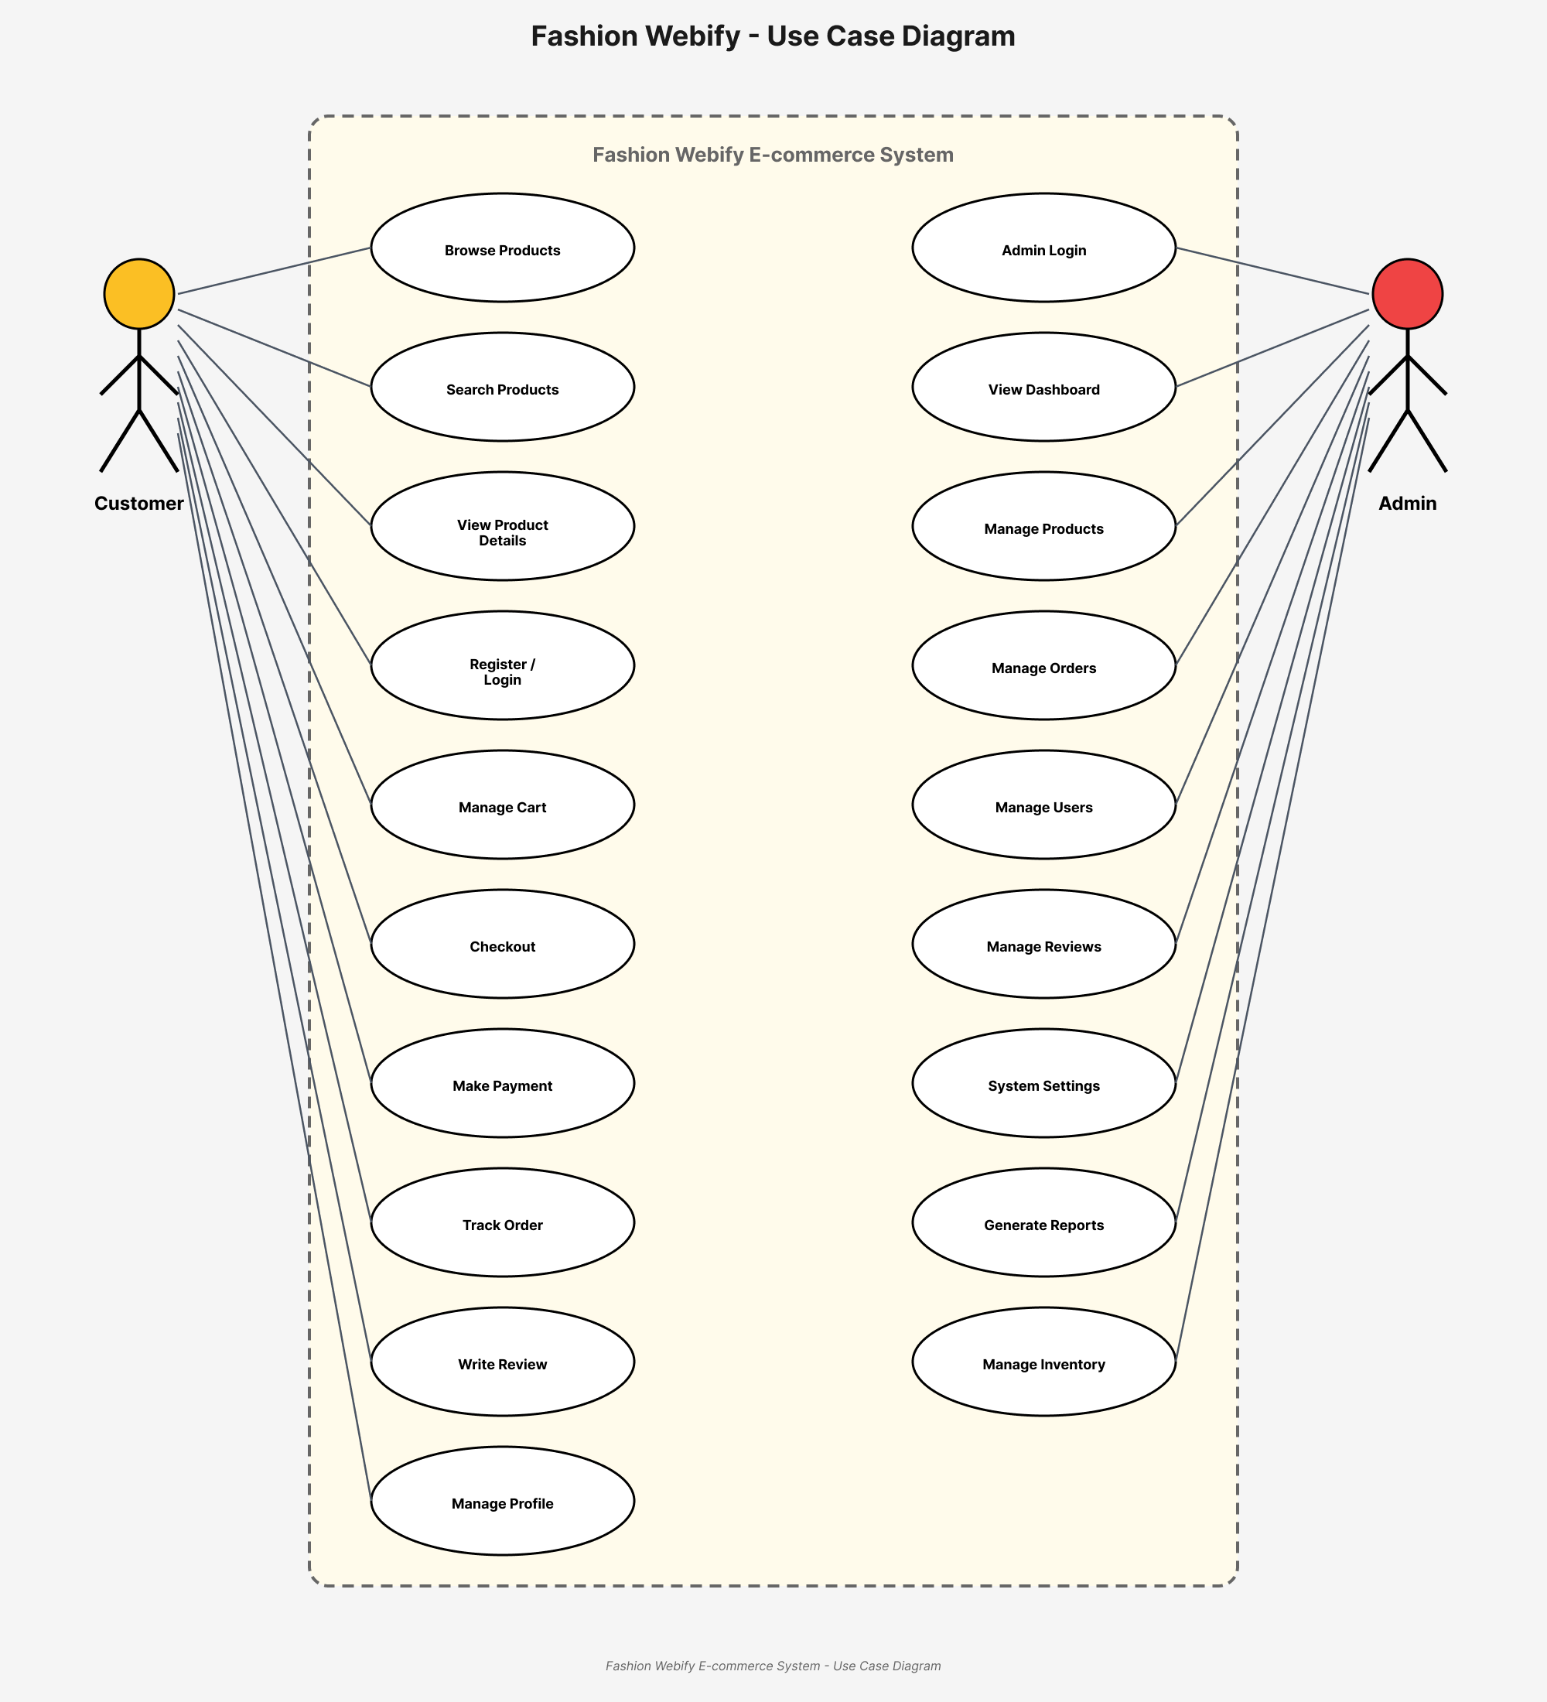
Figure 3. 1 Use Case
- Overview of the Use Case Diagram
The use case diagram (Figure 1) represents the functional model of the Fashion Webify online shopping platform. It visually shows how three main actors—Customer, Admin, and Payment Gateway interact with the system.
Each oval in the diagram represents a use case, meaning a function the system provides.
Lines between actors and use cases represent how users initiate actions inside the system.
This diagram helps in understanding how different users perform tasks like browsing products, placing orders, managing products, viewing reviews, and processing payments.
- Primary Actors in the System
There are three main actors identified:
- Customer
End-users who shop for garments online. They perform actions like registering, logging in, browsing products, placing orders, tracking orders, reviewing items, and chatting with the AI Assistant
- Admin
Represents the garment store owner or platform manager. They manage products, update and view orders, handle customer reviews, and oversee profile and messaging features.
• Payment Gateway
A third-party system responsible for securely handling customer payments.
Each actor has specific goals and actions they want to perform using the system.
- Use Cases for the Customer
The Customer actor is connected with the following use cases:
- Register
Customers must first create an account in the system. The Register use case allows users to input personal information such as name, email, phone number, and password to sign up.
- Login
After registration, customers use the Login function to access their accounts. This typically includes authentication via email and password.
- Browse Product
Customers can explore all garment items available in the store. This includes viewing product images, descriptions, categories, and prices.
- Filter Products
Customers can narrow down product listings by category, price range, size, or other attributes.
- Place Order
Customers select products, add them to the cart, and confirm an order.
- Enter Delivery Details
A required step when placing an order. Customers provide:
  - Address
  - Contact info
  - Delivery notes
- Leave Review
After receiving products, customers can leave star ratings and text reviews for purchased items.
- Track Order
Allows customers to check their order progress such as:
  - Confirmed
  - Packed
  - Shipped
  - Delivered
- Update Profile
Customers can update their personal details, password, or preferences.
- Use Cases for the Admin
The Admin actor interacts with the system for backend operations, focusing on managing orders and products. The following use cases are associated:
- Manage Products
The Admin can add, edit, or delete garments. This includes updating stock, images, prices, and descriptions.
- View Orders
The Admin can see customer orders, including order details, payment status, and delivery information.
- Update Orders
Admins update order progress confirming, packing, shipping, or completing it.
These updates reflect in the customer’s Track Order section.
- View Reviews
Admins read reviews left by customers to understand product quality and customer satisfaction.
- Use Cases Involving the Payment Gateway
Payments
The Payment Gateway interacts with the system to securely process customer payments.
This includes:
  - Verifying payment details
  - Confirming successful transactions
  - Sending payment status updates to the system
This ensures the Admin and Customer receive accurate payment information.
- Shared Use Cases Between Customer and Admin
Some actions, although initiated by the customer, also require or involve the admin, particularly for communication and process flow.

- Track Order
While this appears as a customer activity, it also relies on the garment updating order statuses.
- Place Order
Though initiated by the customer, the garments play a role in receiving and preparing the order.
- View Reviews
The customer leaves reviews, and the garments reads them. Thus, this is a shared use case.
- Direct Messaging
Customer sends messages to Admin views and replies.
- Relationships and Connectors
- Solid lines indicate that the actor is directly involved in the use case.
- Dashed arrows with <<include>> represent a mandatory sub-process. For example, “Enter Delivery Details” is an included use case within “Place Order,” meaning it is required for completion.
- System Boundary
The large rectangle titled “Fashion Webify” represents the system boundary. All use cases inside this rectangle are part of the system. Anything outside (e.g., the actors) interacts with the system but is not part of it.
- Functional Coverage of the System
This use case diagram comprehensively covers the functionality of an online shopping system:
Table 3. 1 Feature Category for use case
Feature Category | Description
User Authentication | Customers register and log in to the system.
Product Navigation | Users explore clothing categories, view product details, and check availability.
Order Processing | Users add products to the cart, place orders, choose delivery details, and track their order status.
Admin Operations | Admin manages products, updates inventory, handles orders, and views customer activity.
Feedback Mechanism | Customers submit reviews and ratings for products; admin can monitor feedback.
Review System | Users can throw review to the products so that other can identify the product quality.
Payment Integration | Secure online payments are processed through the integrated payment gateway.
- Benefits of This Use Case Diagram
- Clarity of Responsibilities
It clearly shows what each actor can and cannot do.
- Planning and Development
Useful during system design to define scope and allocate development tasks.
- Testing and Validation
Serves as a basis for creating test cases to ensure system functionality.
- Potential Enhancements
The diagram can be improved by:
- Adding Admin actor for platform management.
- Including Payment Processing use case.
- Detailing Notifications for order status changes.
- Representing Customer Support features like chatting or raising complaints.

Detailed Use Case
The tables below indicate a comprehensive use case template filled out for the all use cases in the Fashion-Webify system.
Table 3.2 Login use case
Use case id | 01
Use case name | Login
Actors | - Customer  - Admin
Description | A user logs into their Fashion-Webify account
Trigger | User clicks "Login" button
Pre-condition | The user has a registered account
Postcondition | The user is logged into their account dashboard
Normal flow | - User enters email/phone and password  - System validates credentials  - If valid, system logs user into their account
Alternative flow | - Invalid credentials  - Error message displayed to re-enter details
Exceptions | - Incorrect email/password  - Network error
Business rules | System requires internet connectivity to authenticate login
Assumptions | - Users must log in to place orders or manage a store.  - A "Forgot Password" option will be available.

Table 3.3 Register use case
Use case id | 02
Use case name | Register
Actors | Customer
Description | A non-registered user creates a new account
Trigger | Customer clicks "Register" button
Pre-condition | Customer does not have an existing account
Postcondition | Customer's user profile is created
Normal flow | - System displays registration form  - Customer enters required details and submits  - System validates details and creates user profile  - Customer is registered and can now login
Alternative flow | - Cancel Registration  - Customer clicks cancel, registration stops  - Invalid Data  - System alerts customer to correct errors
Exceptions | - Existing email  - "Email already registered" message  - Incomplete form  - "Please fill all fields" message
Business rules | Active internet connection required
Assumptions | - All users (customers & retailers) must register before accessing features.  - Email and phone verification will be required.

Table 3.4 Browse Products use case
Use case id | 03
Use case name | Browse Products
Actors | Customer
Description | Customers can browse Garments products to view product details
Trigger | Customer clicks "Products" button on a garments page
Pre-condition | Customer is logged into their account
Postcondition | Customer sees the product for the selected garments
Normal flow | - Customer selects “Products” option  - System displays that garments products  - Customer views products names, photos, prices
Alternative flow | - Garments have no products  - Support notification generated
Exceptions | - Server error  - Generic error message
Business rules | Garments must have an active products uploaded
Assumptions | - Customers can browse products without logging in.  - Search, filters, and categories will enhance browsing.

Table 3.5 Place Order use case
Use case id | 04
Use case name | Place Order
Actors | Customer
Description | Customers can place orders for product from a garments through this application.
Trigger | Customer selects desired garments products and proceeds to checkout.
Precondition | Customer is logged into their account and has selected some garments products.
Postcondition | Garments receive the order request and confirm it.
Normal flow | - Customer selects desired products.  - Customer browses through the products.  - Customer adds desired products to the cart.  - Customer proceeds to checkout.  - Customer confirms order details.  - System sends order request to garments.  - Garments receive and confirm the order.  - Customer receives confirmation of order.
Alternative flow | - products are out of stock  - System notifies the customer  - Customer remove products or select alternative  - Garments are closed  - System notifies the customer
Exceptions | - Server error  - Generic error message
Business rules | Customer must be logged in to place an order.  Selected products must be available for delivery.  Products added to the cart must be available and in stock.
Assumptions | - Customers must be logged in to order.  - Stock availability will be checked before confirming an order.

Table 3.6 Enter Delivery Details use case
Use case id | 05
Use case name | Enter Delivery Details
Actors | Customer
Description | Customer provides details for their delivery address and options
Trigger | Customer clicks "Delivery Info" on place order screen
Precondition | Customer account is logged in
Postcondition | Delivery details are captured
Normal flow | - Customer enters name, address, phone  - Customer clicks confirm
Alternative flow | - Invalid data  - Errors shown to correct
Exceptions | - Missing fields  - "Please fill all required fields"  - Server error  - Generic error message
Business rules | Address must be within delivery zone
Assumptions | - Customers must provide a valid delivery address.  - The system will allow pre-saved addresses for faster checkout.

Table 3.7 Filter Product use case
Use case id | 06
Use case name | Filter Product
Actors | - Customer  - Admin
Description | Allows customers to filter products based on different criteria such as category, price range, size, brand, color, and discount offers.
Trigger | The customer selects a filtering option while browsing products
Precondition | The user is on the product browsing page.
Postcondition | The system displays products that match the selected filter criteria.
Normal flow | - Customer navigates to the product listing page.  - Customer selects one or multiple filter options (e.g., price, size, color).  - System applies the filters and updates the product list accordingly.  - Customer reviews the filtered results.  - Customer can reset or modify filters if needed.
Alternative flow | - If no products match the selected criteria, the system displays a "No products found" message and suggests similar products.  - Errors shown to correct
Exceptions | - System fails to load filtered results due to a server error.  - "Please fill all required fields"  - Server error  - Generic error message
Business rules | - Filters should be dynamic and based on available product attributes.  - Users can apply multiple filters at once.  - Reset option should be available to remove all applied filters.
Assumptions | - Customers can filter products by price, size, color, brand, and discounts.  - Multiple filters can be applied simultaneously.

Table 3.8 Leave Review use case
Use case id | 07
Use case name | Leave Review
Actors | Customer
Description | Customers can leave reviews and ratings for products they have ordered through this application.
Trigger | Customer selects a products they have ordered and chooses to leave a review.
Pre-condition | Customer is logged into their account and has previously ordered the garments products.
Postcondition | Review is submitted for the selected products.
Normal flow | - Customer navigates to the "Recent Orders" section.  - Customer selects the specific order containing the garments products they want to review.  - Customer finds the desired garments products within the order details.  - Customer selects the option to leave a review for the chosen the products.  - Customer writes a review for the products.  - Customer submits the review and rating.  - System records the review and rating for the respective products.  - Other users can view the review and rating for the garment’s products.
Alternative flow | - Customer decides to not leave a review  - Customer exits the review submission process.
Exceptions | - Server error  - Generic error message returned
Business rules | - Customer must be logged in to leave a review.  - Customer can only leave a review for products they have previously ordered.  - Customers cannot modify or delete their reviews once submitted
Assumptions | - Only customers who have purchased a product can leave a review.  - Reviews will be moderated to prevent spam or inappropriate content.

Table 3.9 Track Order use case
Use case id | 08
Use case name | Track Order
Actors | Customer
Description | Customers can track the status and location of their order from the moment it is placed until it is delivered.
Trigger | Customer selects the option to track their active order.
Precondition | Customer is logged into their account and has an active order.
Postcondition | Customer can monitor the status and location of their order in real-time.
Normal flow | - Customer selects the active order from their account dashboard.  - System displays the current status of the order (e.g., confirmed, preparing, on the way, delivered).  - System provides estimated delivery time of the order.  - Customer receives notifications for important order status updates (e.g., order confirmed, order out for delivery).  - Once the order is delivered, the system updates the status to "delivered" and provides a summary of the completed order.
Alternative flow | - Delivery driver encounters a delay  - Notify the customer of delay
Exceptions | - Server error  - Generic error message
Business rules | - Customer must be logged in to track an order.  - Order tracking information should be updated in real-time.
Assumptions | - Customers can track their order status in real time.  - Notifications will be sent for major updates (Processing, Shipped, Delivered).

Table 3.10 View Orders use case
Use case id | 9
Use case name | View Orders
Actors | - Customer  - Admin
Description | Admin can view the list of orders received from customers through this application.
Trigger | Admin accesses the "View Orders" section within their Garments account.
Pre-condition | Admin is logged into their Garments account.
Postcondition | Admin can view details of each order received, including order contents, customer details, and order status.
Normal flow | - Admin navigates to the "View Orders" section within their garment account dashboard.  - System displays a list of all received orders.  - Admin selects a specific order from the list to view its details.  - System displays the details of the selected order.  - Current status of the order (e.g., confirmed, preparing, on the way, delivered)  - Admin can update the status of the order (e.g., mark as prepared, mark as delivered) based on the progress.  - System automatically updates the order status and notifies the customer accordingly.
Alternative flow | - No orders received  - System displays a message indicating that there are no orders currently.
Exceptions | - Server error  - Generic error message
Business rules | - Only Admin with appropriate permissions can access the "View Orders" section.  - Order details should be displayed accurately and updated in real-time to reflect the latest status.  - Admin should handle orders promptly and update their status to keep customers informed about the progress of their orders.
Assumptions | - Customers and retailers can view order history.  - Order details (products, price, status, expected delivery) will be shown.

Table 3.11 View Reviews use case
Use case id | 10
Use case name | View Reviews
Actors | - Customer  - Admin
Description | Admin can check the reviews and ratings left by users on products offered by their garments through the application.
Trigger | Admin accesses the "User Reviews" section within their garments account.
Precondition | Admin is logged into their Garments account.
Postcondition | Admin can view and respond to user reviews.
Normal flow | - Customer navigates to "Profile Settings."  - The system displays the current profile details.  - Customer edits the necessary fields.  - Customer saves the changes.  - System updates the information and confirms the update.
Alternative flow | - If the customer does not provide valid information, the system displays an error message.
Exceptions | - Server error  - Generic error message
Business rules | - Only Admin with appropriate permissions can access the "User Reviews" section.  - Reviews should be displayed accurately and updated in real-time to reflect the latest feedback from users.
Assumptions | - Customers can see reviews left by other users.  - Retailers can view and respond to reviews about their products.

Table 3.16 Add Product use case
Use case id | 15
Use case name | Add Product
Actors | - Admin
Description | Admin adds new garments by entering details such as name, price, category, description, and images.
Trigger | Admin selects "Add Product" option.
Precondition | Admin has required permissions.
Postcondition | New product is successfully added to the catalog.
Normal flow | - Admin logs in.  - Navigates to Product Management  - Fills in product details  - Submits the new product.
Alternative flow | If images are missing, the system prompts the admin to upload them.
Exceptions | - Incorrect data format prevents submission.
Business rules | - Only admins can add new products.  - Each product must have a unique identifier (SKU).
Assumptions | - The system validates product details before adding them.

Table 3.17 Update Product use case
Use case id | 16
Use case name | Update Product
Actors | - Admin
Description | Admin modifies existing product details such as price, stock, and descriptions.
Trigger | Admin selects a product for editing.
Precondition | Product exists in the catalog.
Postcondition | Product details are successfully updated.
Normal flow | - Admin logs in.  - Navigates to Product List.  - Selects a product to edit.  - Updates details and saves changes.
Alternative flow | If the price changes drastically, the system asks for confirmation
Exceptions | - System error may prevent saving changes.
Business rules | - Only admins can update product details.  - Price changes require admin approval.
Assumptions | The system logs changes for audit purposes.

Table 3.18 Delete Product use case
Use case id | 17
Use case name | Delete Product
Actors | - Admin
Description | Admin removes discontinued or out-of-stock products from the catalog.
Trigger | Admin selects "Delete Product" option.
Precondition | Product exists in the system.
Postcondition | Product is removed from the catalog.
Normal flow | - Admin logs in.  - Navigates to Product List.  - Selects the product for deletion.  - Confirms deletion.
Alternative flow | If the product has pending orders, the system prevents deletion.
Exceptions | System downtime may cause failure.
Business rules | - Only authorized admins can delete products.  - Deleted products cannot be restored.
Assumptions | The system maintains logs of deleted products.

Table 3.19 Make Payments use case
Use case id | 18
Use case name | Make Payments
Actors | - Customer  - Payment Gateway
Description | Customers can complete purchases using different payment methods.
Trigger | Customer proceeds to checkout and selects a payment method
Precondition | - The user has added products to the cart and is logged in.
Postcondition | - Payment is processed, and the order is confirmed.
Normal flow | - Customer selects payment method (stripe, COD etc.).  - System redirects to the payment gateway.  - Customer enters payment details.  - System processes the transaction.  - Payment confirmation is displayed, and an order is placed.
Alternative flow | If payment fails, system prompts user to retry or select a different payment method.
Exceptions | - Transaction failure due to bank issues.  - Network connection lost during payment.
Business rules | - System must ensure secure transactions.  - Orders are not confirmed until payment is verified.
Assumptions | - Multiple payment methods (credit/debit card, mobile wallets, COD) will be supported.  - Payments will be securely processed via an integrated gateway.

Functional Requirements
The project is divided into two main modules:

Customer Module
- Authentication
Customers can register accounts and log in securely to access personalized features, including saved profiles and order history.
- Product Browsing
Customers can explore various clothing categories, filter products by size, price, or brand, and view detailed product descriptions and images.
- Placing Orders
Customers can add products to their cart, enter delivery details, choose payment method, and confirm their order using a secure checkout system.
- Reviewing Product
Customers can leave ratings and written feedback on purchased clothing products to help others make informed buying decisions.

Admin Module
- Product Management
Allows garment owners to add new clothing products, update product details, adjust prices, manage stock levels, and remove outdated products.
- Viewing Orders
Displays all customer orders with product details, delivery addresses, and order statuses so the owner can process and dispatch orders efficiently.
- Sales insights
Provides detailed sales analytics such as top-selling products, total revenue, and customer purchase patterns to support business decision-making.
These requirements are outlined to ensure the platform meets all expected functions and delivers a comprehensive ordering experience.

Non-Functional Requirements
The system also incorporates several key non-functional requirements:
- Usability
Clean, user-friendly interface across devices to ensure smooth navigation and ease of use for all users, including first-timers.

- Performance
Fast load times and real-time updates are ensured by optimized backend services and lightweight front-end components.
- Portability
Works across Android, iOS, and major web browsers using ReactJS for consistent performance across platforms.
- Scalability
System architecture supports adding more garments and customers without performance loss, using cloud-based infrastructure and modular design.

Chapter 4

Design and Architecture

Design and Architecture
From the SDD, this chapter covers the structural and technical design of the system.

System Architecture
Garments Fashion-Webify” follows a client–server architecture. The frontend (ReactJS) interacts with the backend (Node.js + Express.js) through RESTful APIs. MongoDB is used as the primary database for storing users, products, orders, and reviews. This architecture ensures smooth, scalable, and efficient communication between all system components.


Fashion Webify
Architecture

Presentation Layer

Application

Layer

Data

Layer

React.js

Node.js

MongoDB

Figure 4. 1 Architecture Diagram
- Introduction to System Architecture
System architecture defines the components or modules, their interactions, and data flow among them. In this context, the architecture diagram of "Fashion Webify " shows how a user’s request (e.g., placing an order or tracking it) flows through multiple layers client, server, database, and external services—to deliver the required output.
- Overview of Components
The architecture comprises the following main sections:
- Client Side
The frontend interfaces the user interacts with.
- Server Side
Where the backend logic is handled, using Node.js.
- Database
A MongoDB database for storing application data.
- External Services
Third-party APIs for features like order tracking.
Each part is responsible for specific tasks, and their interaction ensures system functionality.
- Client Side
- User Interaction
- The system begins with the User who interacts with the application via a frontend interface called Fashion Webify .
- The interface is responsible for accepting input (e.g., placing an order, browsing product) and displaying output (e.g., order status).

- Fashion Webify Interface
This is the core client-side component that facilitates user interaction. It includes:
- UI Components
  - These are the visible elements like buttons, forms, products, images, etc.
  - They provide the structure and visual feedback necessary for a seamless experience.
  - Examples include the "Place Order" button, order tracking display, or login form.
- Client Responsibilities
- Displaying the user interface.
- Accepting user input and forwarding it to the server.
- Temporarily caching data for better performance.
- Making API calls to fetch or send data.
- Server Side
The Server Side is the backend that handles data processing and applies business rules.
- Node.js
- The backend is built using Node.js, a JavaScript runtime known for handling asynchronous operations efficiently.
- Node.js receives requests from the frontend (e.g., new order, login, products fetch) and delegates them to the appropriate backend functions.
- Business Logic
- This layer contains the rules and functions that govern how the system behaves.
- It processes the requests—e.g., validating user inputs, calculating delivery estimates, determining discounts, verifying user login credentials.
- After processing, it either returns the result directly or updates the database.
- Interactions with MongoDB
- The processed data is stored or retrieved from the MongoDB database.
- Examples:
  - Saving a new order.
  - Retrieving Garment products.
  - Updating user details.
  - Checking order statuses.
- Database Layer – MongoDB
- MongoDB is a NoSQL database used to store data in flexible, JSON-like documents.
- It is suitable for dynamic applications like E-Garments "Fashion-Webify", where data formats (e.g., different clothing products, sizes, colors, and user preferences) may vary.
- It is used for:
  - Storing user data (e.g., profile, addresses).
  - Recording orders and their statuses.
  - Managing Garment data (product, availability).
  - Keeping review and feedback history.
- Flow of Data
- Node.js fetches or updates data using MongoDB queries.
- The database returns the required information.
- Node.js formats the result and sends it to the frontend.
- External Services
The architecture incorporates External Services, which the application utilizes for specialized functions that are not handled internally.
- Track Order
- This service fetches the current location of the delivery agent and allows customers to track the delivery status on a map.
- How Components Work Together: Example Flow
Let’s walk through a typical user journey to understand component interaction.
- Step-by-Step Order Placement and Tracking
- User opens the Fashion Webify App
  - Interacts with UI Components (Client Side).
- User browses the product and places an order
  - UI collects input and stores cart data in Async Storage.
  - Sends the order request to the Node.js backend.
- Server processes the request
  - Node.js checks business logic.
  - Data is stored in MongoDB (new order entry).

- User wants to track the order
  - Frontend calls the backend to get tracking info.
  - Backend uses the Socket to get real-time delivery status.
  - Updates frontend with tracking data.
- Order is delivered
  - Server updates MongoDB with delivery status.
  - User sees “Delivered” status on UI.
- Key Benefits of This Architecture
Table 4. 1 Benefits of Architecture Diagram
Feature | Benefit
Modular Components | Allows independent management, updating, and scaling of each website component, such as the product catalog, user accounts, and orders.
Node.js Backend | Efficiently handles multiple requests simultaneously through non-blocking I/O..
MongoDB Storage | Flexible and scalable data model ideal for dynamic user and order data.
External APIs | Real-time tracking and value-added services without building in-house.

- Future Enhancements
To make this architecture more robust, the following can be considered:
- Introduce Notification System (SMS/email updates).
- Add an Analytics Dashboard for the admin to track sales, popular products, and customer behavior.

Data Representation [Diagram + Description]
The database contains multiple collections/tables
- Users
Stores login info, roles, and personal data.
- Garments
Product, profile, operating hours.
- Products
Clothing products including name, category, sizes, colors, price, and availability4.
- Orders
Customer orders and status.
- Reviews
Customer feedback on orders. Each entity is designed to normalize data and ensure integrity.

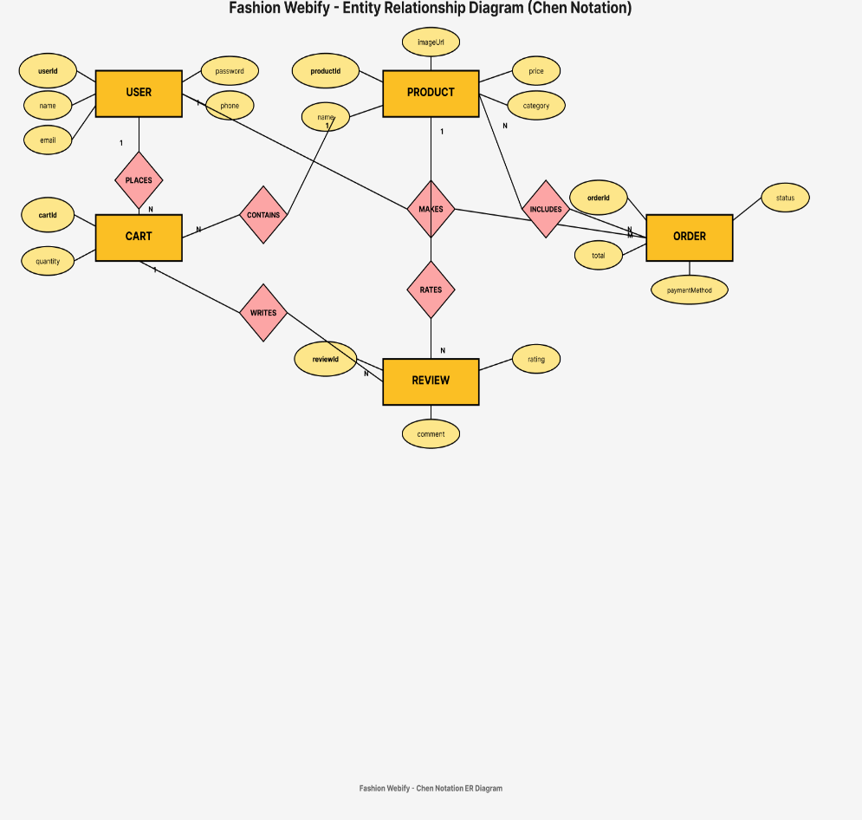

Figure 4. 2 ER Diagram

- Introduction
An Entity Relationship Diagram (ERD) is used to represent the logical structure of a database, showing the entities, their attributes, and the relationships among them.
This ERD represents the data model of an “Fashion Webify” an online clothing store that includes key entities such as customers, orders, product, delivery boys, and addresses.

- Entity: Customer
The Customer is main character to this system. This entity contains:
- Customer ID
A unique identifier for each customer. Acts as the primary key.
- Name
  - FirstName
  - LastName
The Customer entity is linked to:
- Address entity (to store where the order is to be delivered).
- Orders entity (indicating that each customer can place one or more orders).
- Entity: Address
Each customer has an associated Address, broken down into:
- Address1
Street address or main address line.
- City
The city for the delivery.
- Zip code
Postal code of the location.
- State
State or region.
This modular structure allows for precise and flexible address recording, which is crucial for delivery logistics.
- Entity: Orders
The Orders entity represents each clothing order placed by customers. Key attributes include:
- Order ID
A unique identifier for each order.
- Cust ID
Foreign key that links back to the Customer entity.
The relationship is one-to-many a customer can place many orders, but each order belongs to only one customer.
The Orders entity connects to:
- Order Product (through which products are associated with the order).
- Delivery (to assign a delivery boy to the order).
- Entity: Order Product
The Order Products is a junction table that links Orders with Products. An order can contain multiple products, and a product can appear in multiple orders.
Key attributes of OrderProduct:
- OrderProductID
Primary key.
- OrderID
Foreign key linking to the Orders table.
- ProductID
Foreign key linking to the Product table.
- Quantity
Number of units ordered for a particular products.
- Price
Price per unit at the time of ordering.
This structure allows for detailed breakdowns of each order.
- Entity: Product
The Product entity stores information about all the Clothing products available in the system.
Attributes include:
- ProductID
Primary key for each product.
- ProductName
Name or description of the product.

- Product Category
E.g., Men’s Wear, Women’s Wear, Accessories.
- Size
Available sizes (S, M, L, XL, XXL).
- Color
Product color options.
- Price
The price at which the Product is sold.
- Review
A textual and numerical rating/review.
Each Product can be associated with multiple OrderProduct entries, reflecting sales across different orders.
Each order is assigned to one delivery boy, forming a one-to-many relationship between Delivery Boy and Orders (one delivery boy can deliver multiple orders, but each order has one delivery boy).
Relationships Summary
Table 4. 2 Relationships Summary
Relationship | Entities Involved | Type | Explanation
Customer – Address | Customer, Address | One-to-One | A customer contains one address.
Customer – Orders | Customer, Orders | One-to-Many | One customer can place multiple orders.
Orders – OrderProduct | Orders, OrderProduct | One-to-Many | Each order can have multiple Product.
OrderProduct – Product | OrderProduct, Product | Many-to-One | Each order Product entry is linked to a single product.
Orders – Delivery | Orders, Delivery Boy via Delivery | Many-to-One | Each order is delivered by one delivery boy.

- Normalization
The design of this ERD reflects the principles of database normalization, especially 3NF (Third Normal Form):
- No repeating groups
Each piece of data is atomic.
- No partial dependencies
Every non-key attribute depends on the whole key.
- No transitive dependencies
non-key attributes only depend on the primary key.
This results in:
- Minimal data redundancy.
- Easier data maintenance.
- Improved consistency and data integrity.
- Practical Scenario Walkthrough
Let’s walk through a real-world example using this ERD.
Scenario: A customer places an order
- A new Customer is registered with Customer, Name, and image.
- The customer places an Order (OrderID), linked to their Customer.
- The OrderProduct is filled with selected products, each linked to the Product through ProductID.
- The order contains:
  - Quantity of each product.
  - Price of each product at time of order.
- The customer may later submit a Review on the products from the Product entity.
- Use in Application Development
This ERD can be translated into relational database tables during backend development. For instance:
- A Customer table with foreign keys referencing Address.
- A many-to-many join between Orders and Product using the OrderProduct table.
The clean design helps developers implement logic for:
- Order creation
- Delivery tracking
- Product browsing
- Review and rating systems

Process Flow/Representation
The order process is visually represented as:
- User logs in or registers
- User browses product
- User selects products and checks out
- Garments receives the order and prepares it
- Delivery status is updated and tracked in real-time
- User receives the order and may submit a review

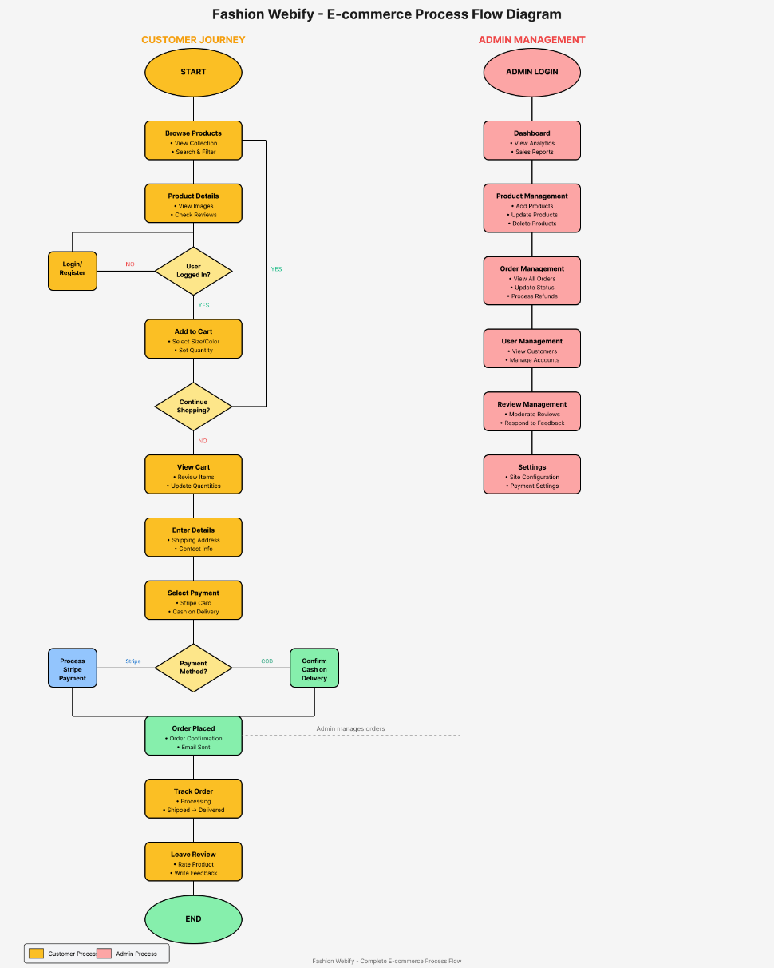
Figure 4. 3 Process flow

  - Start of the System
The system initiates from the "Start" node and branches out into two major user types:
- Admin
- User
Each branch then follows distinct workflows tailored to the needs and permissions of these user roles.
- Garments Flow
Once a Garments owner enters the system, the first step is Login. If the login attempt is successful, the owner gains access to several functionalities. If the login fails, the flow simply halts until correct credentials are provided.
Upon successful login, the garments owner can:
- Manage Inventory
- Add Product
Owners can add new clothing products or accessories to the website’s product catalog.
- Remove Product
Products that are no longer available or out of stock can be removed from the inventory.
- Edit Item
Owners can modify the name, description, price, or availability of any existing Product.
This functionality ensures that the garments has full control over its offerings, reflecting real-time changes to the customer interface.
- Manage Orders
- Update Status
The admin can update the current status of an order—such as "Processing", "Packed", "Shipped", or "Delivered".
- Notify User
Any status updates or custom messages can be sent to users, keeping them informed of their order progress.
This flow ensures clear communication between the garments and the customer, enhancing the user experience.
- Check Product Feedback
- Open Product
Opens details of the product, including average ratings, sizes, colors, and stock availability.
- Check Review
Allows owners to view user-submitted reviews or feedback on individual products. This can help improve service quality and identify areas for improvement.
- Customer Flow
This branch handles the user journey through the E-Garments "Fashion-Webify" application. It begins with a login /registration phase and follows through the process of browsing, ordering, and reviewing.
- User Registration and Login
- If the user is not registered, they are prompted with "Register Please" and are taken to the registration page.
- If already registered, they move to the Login phase.
- If Login Fails, the system asks for re-entry of credentials.
Only upon successful login can users access the system's main features.
- Profile Management
- Update Profile
Users can upload or change their profile image.
- Browsing and Searching
- Search Product
Users can search for clothing products or accessories based on keywords, categories, or filters.
- Check Order History
Displays the list of previous orders made by the user.
- View Product
- Displays details about a selected product, including description, price, available sizes/colors, and user ratings.
These features help users make informed decisions while ordering.

- Cart and Checkout
- Add to Cart
Adds the selected products to the user’s shopping cart.
- Cart
Shows all added products, including quantities, subtotal, and any applied discounts or taxes.
- Checkout
Proceeds to the payment and order confirmation page.
- Payment Process
- Payment
A decision node checks if the payment was successful.
  - No → Payment Failed: The system prompts the user to retry or use a different payment method.
  - Yes → Do Payment: The payment is processed and confirmed.
Once the payment is successful, the order is considered placed.
- Order Management
- Placed Order
Confirms that the order has been successfully submitted to the garments.
- Order Tracking
Allows users to track their order status in real-time.
- Order Delivery
Final step where the user receives the order.
This flow ensures a smooth and transparent experience from cart to delivery.
- Feedback
- After the order is delivered, users are prompted to leave feedback.
- This feedback can include ratings, textual reviews, and is visible to both garments owners and other users.

- Logout
Both users (garments owners and customers) can logout from the system once their tasks are completed. This returns them to a safe exit point and secures their session.
- Flow Structure Overview
The flowchart is designed using standard flowchart symbols:
- Terminator nodes (rounded rectangles) for Start, Logout.
- Decision nodes (diamonds) for logical conditions (e.g., "Login?", "Registered?", "Payment?").
- Processes (rectangles) for each action, like "Add Product", "Search Product", "Checkout", etc.
- Connectors/Arrows to indicate the direction of flow.
Each component is logically connected, showing the dependencies between user actions and system responses.

Design Models

Sequence Diagram
Illustrates the flow of actions from the user placing an order to receiving it.
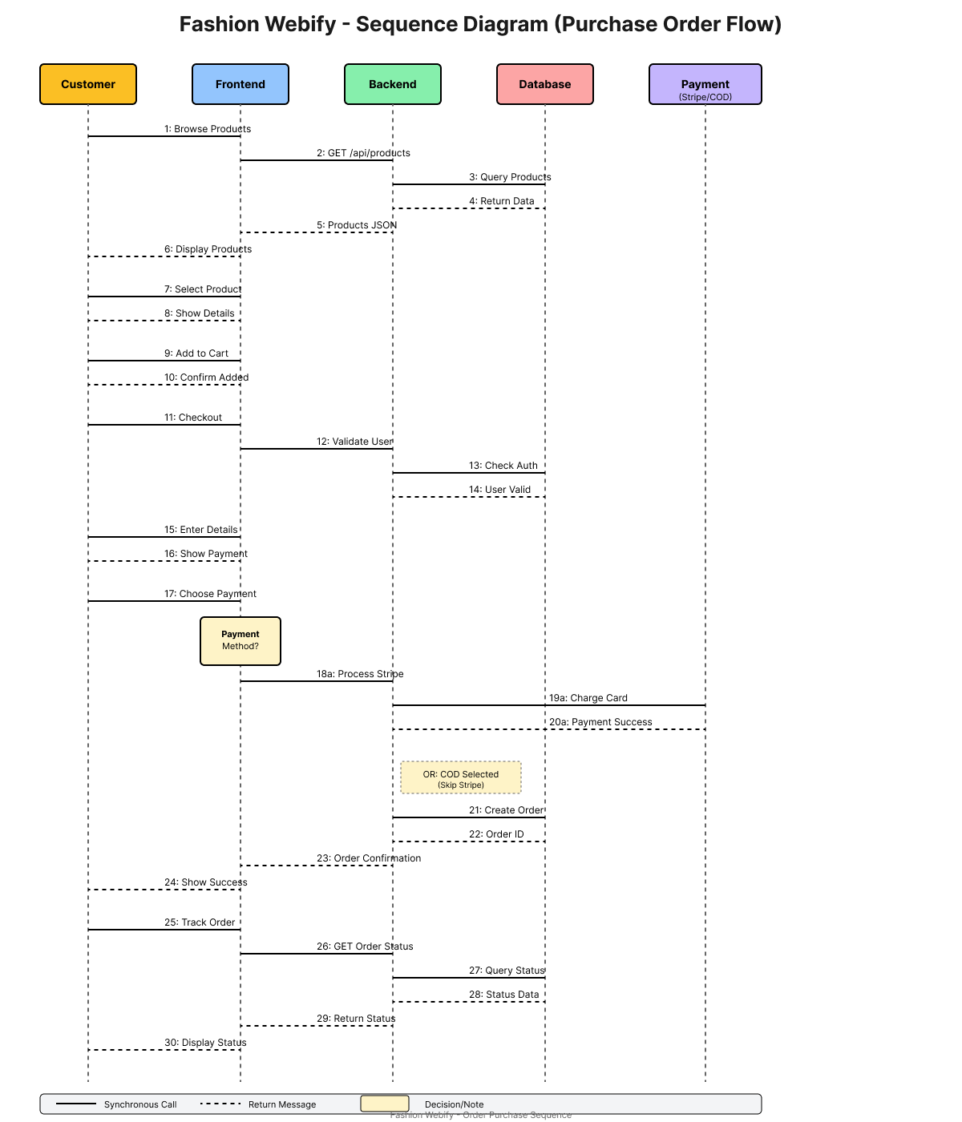
Figure 4. 4 Sequence Diagram
- Participants and Their Roles

- Customer
The primary end-user who interacts with the application to browse garments, place an order, and complete payment.
- Fashion-Webify (System)
The central backend logic of the platform that handles customer requests, manages state, coordinates with the database.
- Database
Stores persistent data, including user credentials garments product, order details, and transaction records.
- Garments
Represents the vendor or store that manages the products, processes orders, and ensures timely dispatch and delivery to customers.
- Sequence of Operations (Step-by-Step Explanation)
Step 1: Authentication Process
- Customer → Fashion-Webify: Authentication
The customer initiates a login or authentication request.
- Fashion-Webify → Database: Auth Request
The system sends the credentials (e.g., username, password) to the database to verify user identity.
- Database → Fashion-Webify: Auth Successful
Once verified, the database returns a success response.
This authentication step ensures that the user is valid and authorized to use the system.
Step 2: Garments Selection and Products Retrieval
- Customer → Fashion-Webify: Select garment
After login, the customer selects a product category (e.g., Men, Women, Accessories) or a specific store/brand.
- Fashion-Webify → Database: Fetches Product
The system queries the database for product listings under the selected category or brand.
- Database → Fashion-Webify: Return Product Listing
The database returns product details including name, size, price, colors, images, and availability.
- Fashion-Webify → Customer: Display Product
The user interface displays the retrieved product list for browsing.
Step 3: Add to Cart
This step occurs inside a loop, meaning it can be repeated multiple times depending on how many products the customer wishes to add.
- Customer → Fashion-Webify: Add to Cart
Each time a customer adds a product to the cart, this request is triggered.
- Fashion-Webify → Customer: Added Confirmed
The system confirms that the selected product has been successfully added to the cart.
This iterative process allows customers to build their order before proceeding to checkout.
Step 4: Checkout and Order Confirmation
- Customer → Fashion-Webify: Checkout
The customer initiates the checkout process once satisfied with their cart.
- Fashion-Webify → Garments: Order Confirmation
The system sends the finalized order details to the admin for processing.
- Garments Admin → Fashion-Webify: Confirms Order
The store acknowledges the order and begins packaging and dispatch preparation.
This step establishes the official start of the order fulfillment process on the garments end.
Step 5: Payment Processing
- Customer → Fashion-Webify: Makes Payment
The customer provides payment details (COD).
- Fashion-Webify → Customer: Order Confirmation
The system notifies the customer that the order has been confirmed.
Step 6: Order Delivery
- Garments Admin → Customer: Receives Order
The final stage occurs when the store dispatches and delivers the order to the customer through their delivery system or a partner service.
This completes the transaction lifecycle from browsing to delivery.
- Features of the Diagram

- Synchronous Communication
All the interactions shown are synchronous calls, indicated by solid lines with filled arrowheads. This means each message waits for a response before continuing, ensuring sequential integrity.
- Object Lifelines
Each participant has a lifeline (dashed vertical line) that extends downwards, indicating their existence over the duration of the interaction.
- Loop Notation
The loop symbol enclosing "Add to Cart" denotes that this action can happen multiple times dynamically, based on user behavior.
- Importance in System Design
This sequence diagram plays a critical role in:
- Clarifying communication protocols between modules and external services.
- Validating system logic for correctness and completeness.
- Serving as documentation for developers, QA engineers, and stakeholders.
- Enhancing maintainability, especially during debugging or system updates.
- Summary of User Experience Flow
- User logs in securely.
- Browses through the garment categories and selects a specific vendor or brand.
- Views product details such as images, sizes, colors, and price.
- Selects one or multiple products and adds them to the cart.
- Proceeds to checkout to confirm delivery details and make payment.
- Receives order updates after vendor confirmation until the product is delivered.
This flow is designed for efficiency, clarity, and security, ensuring a smooth user experience while also accommodating backend processes.

Class Diagram
The diagram illustrates the main system classes with their attributes and methods, showing how core components User, Garments, Product Item, Order, and Review are interconnected. These relationships define data flow and module interaction, supporting key functions like user management, product browsing, order processing, and customer feedback.
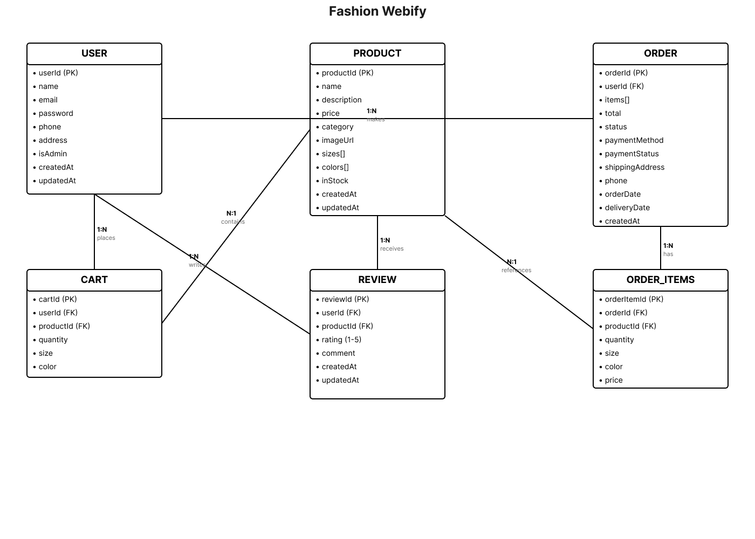
Figure 4. 5 Class Diagram

  - User Class

- Attributes:
- Name
The full name of the user.
- Email
Email ID used for login and communication.
- Password
Encrypted password for account access.
- Phone
Contact number.
- Role
Enum type that distinguishes between Customer, Admin, and Garments Owner.
- Address
User’s delivery address.
- order History
A list of orders made by the user.
- profile Picture
Reference to a stored image for the user's avatar.
- Methods:
- register()
Used to create a new user account.
- login()
Authenticates the user into the system.
- update Profile ()
Allows updating user details (like name, address, etc.).
- Relationships:
- A User has many Payment Methods (1 to many).
- A User has many Orders (1 to many).
- A User can write many Reviews (1 to many).
This class is central to the system as it supports multiple user types, enabling different roles to access tailored functionalities.
- Product Class

- Attributes:
- name, description, price: Basic details about the product.
- Category
Enum representing product type (e.g., Men, Women, Accessories).
- Reviews
Linked to Review objects.
- Image
Link or ID for the item image.
- Availability
Boolean indicating if the item is currently available.
- update Availability(status)
Method to toggle availability.
- add Review ()
Allows customers to submit reviews for a product.
- Relationships:
- A Product Item is linked to exactly one Garments (many-to-one).
- A Product Item can have many Reviews (1 to many).
This class is essential for representing the catalog of products available for purchase, enabling dynamic updates and user interaction.
- Order Class

- Attributes:
- Status
Enum—Pending, Completed, or others (e.g., Canceled).
- Garments
Reference to the vendor fulfilling the order.
- Products
List of Order Item objects selected by the customer.
- order Date
Date the order was placed.
- placed Order ()
Function to initiate order creation.
- update Status ()
For order tracking (e.g., Accepted, Preparing, Delivered).
- cancel Order ()
Enables order cancellation before a defined status.
- Relationships:
- One Order is placed by one User.
- One Order contains many Order Items (1 to many).
- One Order is assigned to one/multiply Garments.
The Order class acts as a bridge between the user and the Garments, representing all key transactional information.
- Order Item Class

- Attributes:
- Productized
Reference to the selected Product Item.
- Quantity
Number of units ordered.
- Price
Price at the time of order (useful for audit/history).
- Relationships:
- Belongs to one Order.
- References one Product Item.
This class captures individual products within an order, supporting accurate billing and purchase history tracking.
- Review Class

- Attributes:
- itemed
References the product item being reviewed.
- ushered
Reviewer identity.
- Rating
Numeric score, typically between 1 and 5.
- Comment
Optional written feedback.
- created At, updated At
Timestamps for the review.
- delete Review ()
Function to remove the review.
- Relationships:
- A Review links a User to a Product Item.
- Many reviews can be written for the same Product Item.
- Each User can write multiple reviews (but typically one per item per order).
Reviews help in quality assurance, transparency, and user decision-making.
- Entity Relationships Summary
Here’s a quick overview of cardinalities:
Table 4. 3 Class Diagram Relationship
Relationship | Cardinality
User → Payment Method | 1 to 1
User → Order | 1 to many
User → Review | 1 to many
garment → Product Item | 1 to many
Garments → Order | 1 to many
Product Item → Review | 1 to many
Order → Order Item | 1 to many
Product Item → Order Item | many to 1

- Use Cases and Real-World Mapping
- A customer logs into the system, browses a garments vendor’s product catalog, and adds selected products to the cart.
- When the customer places an order, an Order object is created containing multiple Order Item entries, each representing a selected product.
- Payment details are fetched from the user’s Payment Method list.
- After receiving the order, the customer may submit a Review for each purchased Product Item.
- Garments vendors can update their Product Items, manage availability, and monitor all incoming Orders.
This tightly linked structure ensures referential integrity and supports scalable implementation.

Chapter 5

Implementation

Implementation
The implementation of the Fashion Webify system involved developing a full-stack application made up of multiple modules, each tailored to a specific user group: customers, garment owners, and backend administrators. This chapter details the main components of the implementation phase, highlighting how the backend and web interfaces were developed and integrated into a unified system.
The project was developed using the Incremental Software Development Model, enabling iterative progress and early incorporation of key functionalities. This methodology provided flexibility to refine design and logic over time, guided by real-time testing and user feedback throughout implementation. The entire system is built on modern JavaScript technologies:
- Backend
Node.js with Express.js and MongoDB (Mongoose) for RESTful API development.
- Customer Web Portal
Developed using React.js for users preferring a browser-based interface.

Backend Implementation
The backend functions as the central service layer of the system, managing authentication, business logic, data storage, and communication between frontend clients and the database.
Key implementation details include:
- Authentication
JSON Web Tokens (JWT) are used for secure authentication of both users and garments. Passwords are hashed using crypt before storage for enhanced security.
- Routing & Controllers
A modular structure was implemented, separating routes, controllers, models, and middleware. This ensures clean code organization, maintainability, and scalability.
- Database Design
MongoDB collections are structured to support dynamic documents. Key collections include Users, Garments, Product Items, Orders, Reviews, and Images.
- File Uploads
Images are uploaded to the server and linked with Products or garments profiles. Unique UUIDs are used to prevent filename conflicts and ensure uniqueness.

Customer Web Portal Implementation
The customer web portal is a web-based interface designed for desktop and laptop users, providing full access to all system functionalities. It is developed using React.js and communicates with the backend API, ensuring consistent business logic and real-time data handling across the platform.
Implemented components include:
- Home Page
Displays a catalog of garments and stores with search and filtering options to enhance user navigation and product discovery.
- Product View
Allows users to explore detailed product information, including images, sizes, colors, prices, and availability, and add products directly to their shopping cart.
- Checkout Flow
Offers a streamlined process for cart review, order confirmation, and payment processing.
- Responsive Design
Implements responsive layouts to ensure usability and optimal viewing across various screen sizes and devices.

User Interface
The UI of E-Garments “Fashion-Webify” was designed with a focus on user experience (UX) and responsiveness. The system adapts to different screen sizes (desktop, tablet, and mobile).

Web Interface (ReactJS)
- Home Page
Introduction to platform features.
- Product Listing Page
Displays garments organized by categories or brands, with search and filtering options for easy navigation.
- Cart Page
View/edit selected products before checkout.
- Profile Page
View/update personal info and order history.
The interfaces were designed using Figma and implemented using modern UI libraries to ensure consistency and usability.

Chapter 6

API References

API Reference

Authentication

Table 6. 1 Customer Authentication Routes
Endpoint | Method | Description | Parameters
/auth/register | POST | Register customer | email, password, name
/auth/login | POST | Login customer | email, password

Table 6. 2 Garments Authentication Routes
Endpoint | Method | Description | Parameters
/auth/register/garments | POST | Register garments | name, email, password, phone, city, address
/auth/login/garments | POST | Login garments | email, password

Profile Management
Endpoint | Method | Description | Parameters
/:id/profile/image | PUT | Upload profile picture | image (file upload)
/user/:id/profile/update | PUT | Update profile | username, phone, address, location
/images/: imaged | GET | Get uploaded image | -
Table 6. 3 Customer Profile Management Routes

Table 6. 4 Garments Profile Management Routes
Endpoint | Method | Description | Parameters
/garments/:id/profile/:type | PUT | Upload profile/cover image | image (file upload)
/garments/:id/update | PUT | Update garments profile | name, phone, address, location, etc.

Product Items
Table 6. 5 Product Items (Garments Vendor)
Endpoint | Method | Description | Parameters
/garments/:id/product items | POST | Add new product item | name, description, price, cost Price, stock, mastic, ministack, etc. + image
/garments/:id/items | GET | Get all product items | -
/garments/:garmentsId/item/:itemId | GET | Get single item | -
/garments/:garmentsId/item/:itemId | DELETE | Delete item | -
/garments/:garmentsId/items/:itemId | PATCH | Update item | All modifiable fields + image

Garments Discovery (Customer)
Table 6. 6 Garments Discovery (Customer)
Endpoint | Method | Description | Parameters
/garments | GET | List all garments | -
/garments/batch | POST | Get garments by IDs | garmentsIds[]
/garments/items/:itemId | GET | Get single garments item | -
/garments/items/batch | POST | Get multiple items by ID | itemIds[]

Orders & Checkout
Table 6. 7 Customer Orders & Checkout
Endpoint | Method | Description | Parameters
/checkout | POST | Create new order | userId, name, phone, city, address, cart, estimatedDeliveryTime, notes
/user/:userId/orders/active | GET | Get active orders | -
/user/:userId/orders/history | GET | Get historic orders | -
/user/:userId/order/:orderId | GET | Get single order | -
/user/:userId/order/history/:orderId | GET | Get single historic order | -

Table 6. 8 Garments Orders & Checkout
Endpoint | Method | Description | Parameters
/garments/: garmentsId/orders/active | GET | Get active orders | -
/garments/: garmentsId/orders/history | GET | Get historic orders | -
/garments/: garmentsId/order/:orderId | GET | Get order details | -
/garments/:garmentsId/order/history/:orderId | GET | Get historic order | -

Reviews & Ratings
Table 6. 9 Reviews & Ratings
Endpoint | Method | Description | Parameters
/garments/item/:itemId/reviews/:userId | POST | Submit review | rating, comment
/garments/item/:itemId/reviews | GET | Get item reviews | -

Media Handling
Table 6. 10 Media Handling
Endpoint | Method | Description | Parameters
/images/:imageId | GET | Fetch uploaded image | -

Real-Time Features (Socket.IO)
Table 6. 11 Namespaces Real-Time Features (Socket.IO)
Namespace | Path | Description
/user | Customer | Order status updates for customers
/garments | Garments | Live order management

Customer Events
Table 6. 12 Customer Events
Event | Direction | Description | Parameters
join-user-room | Emit | Join private user room | userId
order-created | Receive | New order confirmation | full order object
order-updated | Receive | Order status updated | updated order object
order-removed | Receive | Order cancellation/completion | {orderId, status}
cancel-order | Emit | Request order cancellation | orderId, cancellationReason

Garments Events
Table 6. 13 Garments Events
Event | Direction | Description | Parameters
join-garments-room | Emit | Join garments room | garmentsId
order-created | Receive | New order notification | full order object
order-updated | Receive | Order status change | updated order object
order-removed | Receive | Order moved to history | {orderId, status}
update-order-status | Emit | Update order status | orderId, status

Chapter 7

Testing and Evaluation

Testing and Evaluation
This chapter include the following sections.
- Manual Testing
- Automated Testing

Manual Testing
Manual testing was conducted to ensure that all individual components and integrated modules performed correctly according to the requirements.

System testing
System testing validated the overall functionality of the system in a real-world usage scenario. This ensured that all integrated components (user interface, backend APIs, database, and third-party APIs) worked together seamlessly.
- Objective
Confirm that the entire application operates as intended.
- Scope
Includes full workflows: registration, login, ordering, order tracking, and review submission.
- Result
All test scenarios passed without major defects.

Unit Testing
Each functional unit was tested individually to verify its correctness. Below are examples:
- Unit Testing 1
Login Module
- Objective
Ensure valid login credentials grant access, and invalid ones are rejected.
Table 7. 1 Unit Test 1
No. | Test Case | Input | Expected Result | Result
1 | Valid login | Username: user1, Pwd: 123 | Dashboard loads | Pass
2 | Invalid password | Username: user1, Pwd: xyz | Error: Incorrect password | Fail
3 | Empty fields | - | Error: Fields cannot be empty | Fail

- Unit Testing 2
Edit Profile
- Objective
Ensure profile updates reflect accurately in the system.
Table 7. 2 Unit Test 2
No. | Test Case | Input | Expected Result | Result
1 | Update phone number | New number entered | Profile updated successfully | Pass
2 | Leave required field empty | Remove email | Error: Required field missing | Fail

Functional Testing
Functional testing ensured that the system fulfilled all functional requirements listed in the SRS.
    - Functional Testing
Order Placement
    - Objective
Verify that a customer can place an order and receive confirmation.

No. | Test Case | Input | Expected Result | Result
1 | Add items and checkout | Selected 3 items, filled address | Order confirmed and ID generated | Pass
2 | Attempt to place empty cart | No items selected | Error: Cart is empty | Fail
Table 7. 3 Functional Test

Integration Testing
Integration testing was conducted to ensure proper data flow between system components.
Table 7. 4 Integration Test
No. | Scenario | Input | Expected Outcome | Result
1 | Login to place order | User logs in, selects and checks out | Order confirmation, garments receives order | Pass
2 | Garments receives and marks order prepared | Admin marks status as 'Ready for delivery' | Customer receives live status update | Pass
3 | Submit a review after delivery | Customer rates item | Review saved; average rating updated | Pass

Automated Testing:
Although most testing was manual, a few automated tests were implemented using tools such as Postman.
Table 7. 5 Tool Used
Tool | Description | Applied On | Results
Postman [6] | API testing tool | Login, Register, Place Order APIs | Pass

Automated testing was used to verify data handling accuracy and ensure backend endpoints returned correct status codes and outputs.

Chapter 8

Conclusion and Future Works

Conclusion and Future Work
Summarizes project outcomes and proposes future directions.

Conclusion
The E-Garments “Fashion-Webify” project successfully delivers a full-stack, web-based e-commerce platform for garments and accessories. The system is scalable, user-friendly, and responsive, allowing customers to browse products, place orders, and manage profiles seamlessly. Vendors are provided with an intuitive interface to manage their product catalog, track orders, and view customer feedback.
From requirement analysis and system design to implementation and testing, every phase was executed following established software engineering practices, particularly the Incremental SDLC model. The platform meets all major functional and non-functional requirements outlined in the SRS and has been validated through comprehensive manual and automated testing.
Overall, E-Garments “Fashion-Webify” achieves its goal of providing a modern, flexible, and localized e-commerce solution that addresses limitations found in existing online garment platforms.

Future Work
While the current version of E-Garments “Fashion-Webify” is robust and fully functional, several enhancements can be implemented in future iterations to improve performance, scalability, and user experience:
- Delivery/Logistics Module
A separate module or application can be developed to manage delivery personnel, track shipments, and update order statuses in real time. This ensures timely delivery of products and improves overall customer satisfaction.
- Payment Gateway Integration
Add secure online payment options to provide more flexibility.
- AI-Based Recommendations
Implement recommendation systems to suggest meals based on user preferences or order history.
- Push Notifications
Enable real-time notifications for order status changes, promotions, and reviews.
- Multi-language Support
Add language options to cater to diverse user bases.
- Real Time Tracking
Improve the existing GPS-based delivery tracking system by incorporating live location sharing, estimated arrival times, and customer notifications for every delivery milestone.

References

[1] | • A. Nestler, N. Karessli, K. Hajjar, R. Weffer, & R. Shirvany, “SizeFlags: Reducing Size and Fit Related Returns in Fashion E-Commerce,” arXiv, 2021. arXiv
[2] | • Â. Cardoso, F. Daolio, & S. Vargas, “Product Characterisation towards Personalisation: Learning Attributes from Unstructured Data to Recommend Fashion Products,” arXiv, 2018. arXiv
[3] | • C. Kamanchi, G. A. Kumar, N. Sundaram, R. Babu, & C. Bandi, “An Application of Newsboy Problem in Supply Chain Optimisation of Online Fashion E-Commerce,” arXiv, 2020. arXiv
[4] | • N. Bagam, “Real-Time Data Analytics in E-Commerce and Retail,” Enhanced Research Publications, 2022. ResearchGate
[5] | • F. Mehta, “Development of a Full-Stack E-commerce Website for Inventory Management and Efficient Online Shopping Delivery,” International Journal of Scientific Research & Engineering Trends, Vol. 11, No. 2, 2025. IJSRET
[6] | • H. Dharbale, S. Gaikwad, A. Magar, R. Mane & Prof. V. Gavli, “E-Shop: Web-based E-Commerce Platform with Order Tracking and Inventory Management,” IJARSCT, Vol. 5, No. 1, 2025. IJARSCT
[7] | • A. S. Parihar, “Designing a E-commerce System for a Women’s Fashion Store,” Medium, 2021.
[8] | • A. Nestler, N. Karessli, K. Hajjar, R. Weffer, & R. Shirvany, “SizeFlags: Reducing Size and Fit Related Returns in Fashion E-Commerce,” arXiv, 2021. arXiv
[9] | • Â. Cardoso, F. Daolio, & S. Vargas, “Product Characterisation towards Personalisation: Learning Attributes from Unstructured Data to Recommend Fashion Products,” arXiv, 2018. arXiv
[10] | • C. Kamanchi, G. A. Kumar, N. Sundaram, R. Babu, & C. Bandi, “An Application of Newsboy Problem in Supply Chain Optimisation of Online Fashion E-Commerce,” arXiv, 2020. arXiv

